Name: Lujain Zia
Roll no: 2023-BSE-034
Date: November 7, 2025

Lab 7

Task 1 — Print & filter environment variables
- Print all environment variables:
printenv
Save screenshot as: task1_printenv_all.png
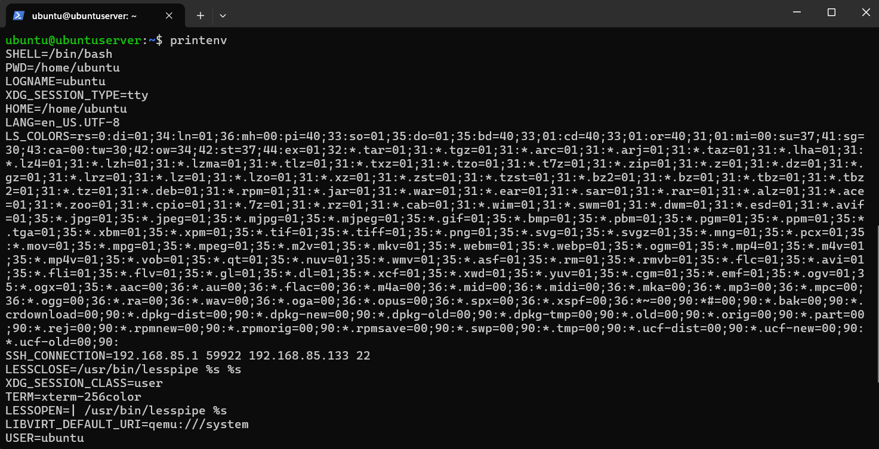
- Filter for SHELL, HOME and USER — run these greps together and capture one combined screenshot:
printenv | grep SHELL
printenv | grep HOME
printenv | grep USER
Save screenshot as: task1_grep_shell_home_user.png (single screenshot showing all three grep outputs together)
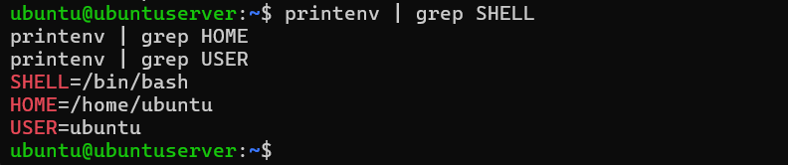
Task 2 — Export DB_* variables temporarily and observe scope

- Define all DB_* variables (run the three exports one after another). Capture them in one screenshot showing the three export commands and their execution:
export DB_URL="postgres://db.example.local:5432/mydb"
export DB_USER="labuser"
export DB_PASSWORD="labpass123"
Save screenshot as: task2_exports_all.png (single screenshot showing all three export commands shown/executed)
- Echo the three variables (run the three echo commands together) and capture one screenshot showing their outputs:
echo "$DB_URL"
echo "$DB_USER"
echo "$DB_PASSWORD"
Save screenshot as: task2_echoes_all.png
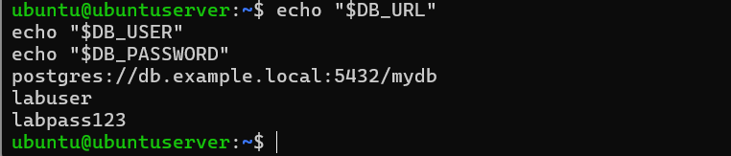
- Show all DB_ variables with a single grep command (capture that output):
printenv | grep '^DB_'
Save screenshot as: task2_printenv_grep_db.png
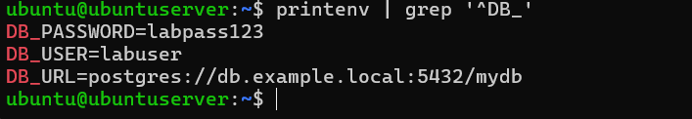
- Close the bash session (e.g., exit) and reopen a new terminal. Verify the variables are gone by running the echo(s) and the grep together; capture both checks in one screenshot:
echo "$DB_URL"
printenv | grep '^DB_'
Save screenshot as: task2_after_restart_checks.png (single screenshot showing echo (empty) and printenv | grep '^DB_' with no results)
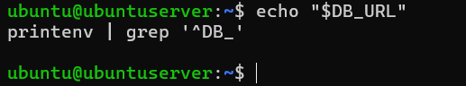

Task 3 — Make DB_* variables persistent in ~/.bashrc
Steps and required screenshots:
- Open ~/.bashrc in an editor and append the three export lines. Capture the editor showing the three lines added (single screenshot):
vim ~/.bashrc
# add at the end
# Lab 7 persistent DB variables
export DB_URL="postgres://db.example.local:5432/mydb"
export DB_USER="labuser"
export DB_PASSWORD="labpass123"
Save screenshot as: task3_bashrc_added.png (single screenshot showing the three export lines in the editor)
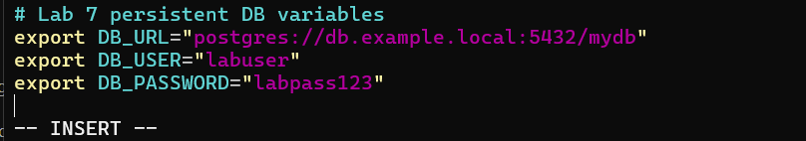
- Source ~/.bashrc and capture the source command in one screenshot together with the next verification commands (grouped): run source ~/.bashrc and then immediately run the three echoes and a single grep, capturing all of these in one screenshot:
source ~/.bashrcecho
"$DB_URL"
echo "$DB_USER"
echo "$DB_PASSWORD"
printenv | grep '^DB_'
Save screenshot as: task3_source_and_verification.png (single screenshot showing source, the three echoes, and the grep output)
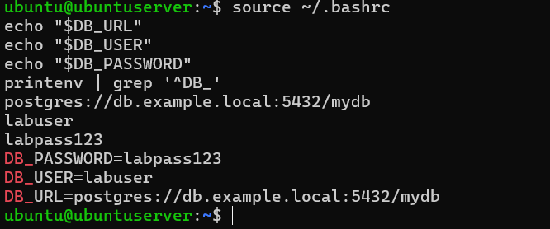
- Close and reopen terminal. Verify persistence by running one echo and the grep together — capture both in one screenshot:
echo "$DB_URL"
printenv | grep '^DB_'
Save screenshot as: task3_after_restart_persistent.png (single screenshot showing echo with value and grep output listing DB_ variables)
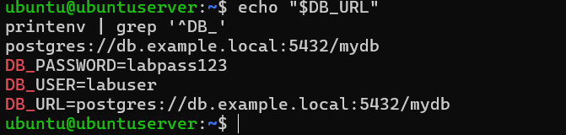
Task 4 — System-wide environment variable, welcome script, and PATH

- View /etc/environment:
sudo cat /etc/environment
Save screenshot as: task4_etc_environment_before.png
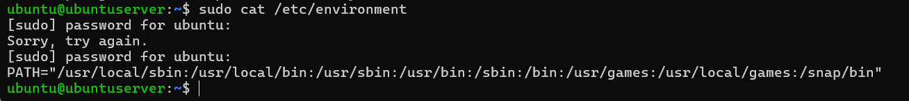
- Show current PATH:
echo "$PATH"
Save screenshot as: task4_echo_path_before.png
- Edit /etc/environment and add Class:
sudo vim /etc/environment
# add line: Class="CC-<your_class_name>"
Save screenshot as: task4_etc_environment_edit_vim.png (editor with edit)
Save screenshot as: task4_etc_environment_after.png (cat or editor view showing the new Class line)
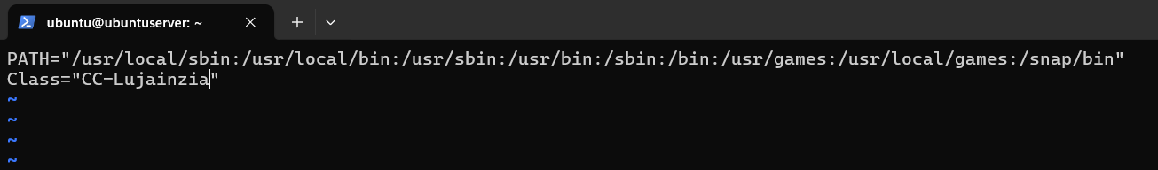
- Re-login or open a new shell and show Class and PATH together (grouped prints): run echo $Class and echo $PATH together and capture in a single screenshot:
echo $Class
echo "$PATH"
Save screenshot as: task4_echo_class_and_path.png (single screenshot showing both outputs)
- Create welcome script at your home directory (~/welcome) and make it executable (capture the heredoc creation and chmod together in one screenshot if possible):
cat > ~/welcome <<'EOF
'#!/bin/bash
echo "Welcome to Cloud Computing $USER"
EOF

chmod +x ~/welcome
Save screenshot as: task4_welcome_create_and_chmod.png (single screenshot showing heredoc creation command and chmod output/listing)
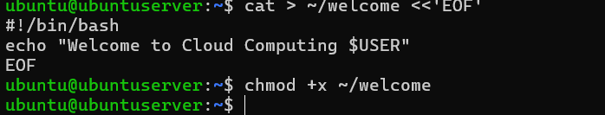
- Run the script from your home directory using ./welcome:
cd ~ ./welcome
Save screenshot as: task4_welcome_run_dot.png
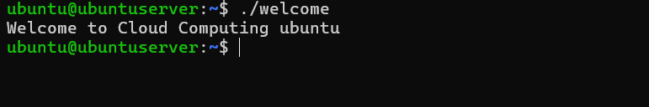
- Add your home directory to PATH in ~/.bashrc. NOTE: per your instruction we do not include an export PATH line here — only add the PATH modification line in the file. Capture the editor showing that PATH line in one screenshot:
vim ~/.bashrc
# add at end:
PATH=$PATH:~
Save screenshot as: task4_bashrc_path_line.png (editor screenshot showing the PATH line only)
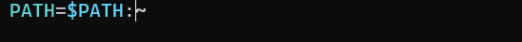
- Apply the change and run welcome — capture these runtime commands in a separate screenshot (must be taken separately from the editor screenshot):
source ~/.bashrccd ~
welcome
Save screenshot as: task4_bashrc_source_and_welcome.png (single screenshot showing the source command and the welcome output)
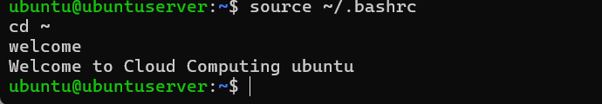

Task 5 — Block and allow SSH using ufw (firewall)
1.Enable ufw and show status (group both commands in one screenshot if you run them together):
sudo ufw enable
sudo ufw status verbose
Save screenshot as: task5_ufw_enable_and_status.png
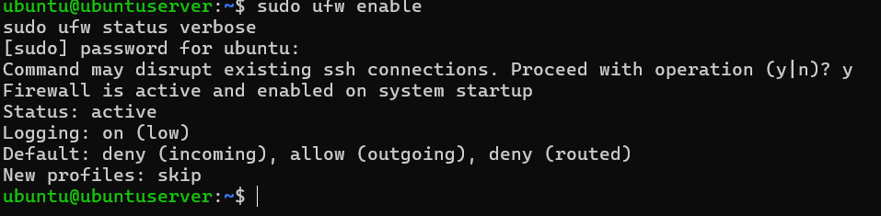
2.Deny TCP port 22 and show status (run deny and status numbered together and capture in one screenshot). Use short form as requested:
sudo ufw deny 22/tcp
sudo ufw status numbered
Save screenshot as: task5_ufw_deny_22_and_status.png
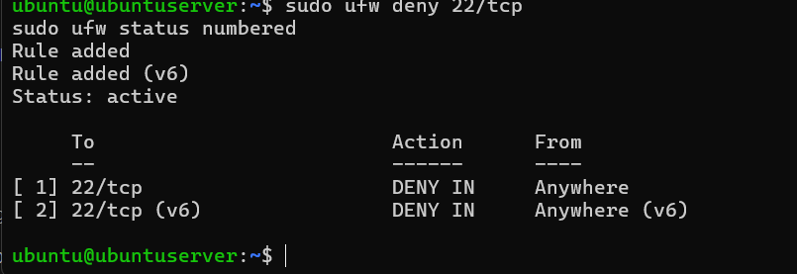
3.From Windows host attempt to SSH (expected to fail) — capture the host-side SSH attempt in one screenshot:
ssh username@<server_ip>
Save screenshot as: task5_ssh_attempt_blocked.png

4.Allow SSH back and reload, then show status (group allow, reload, status in one screenshot if run together). Use short form as requested:
sudo ufw allow 22/tcp
sudo ufw reload
sudo ufw status
Save screenshot as: task5_ufw_allow_reload_status.png
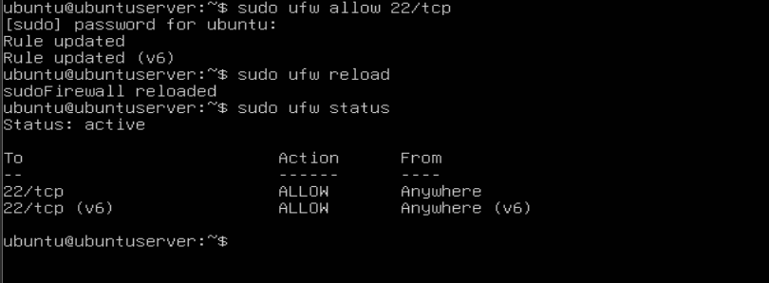
5.From Windows host attempt SSH again (should succeed) — capture successful login in one screenshot:
ssh username@<server_ip>
Save screenshot as: task5_ssh_success_after_allow.png
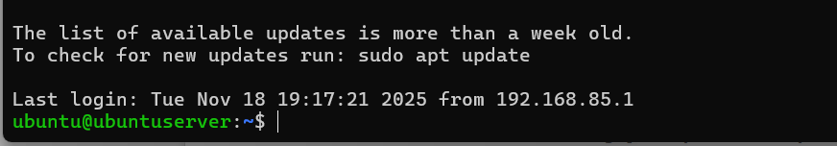

Task 6 — Configure SSH key-based login from Windows host
A. On Windows host (client) — group related client actions:
- Generate ed25519 key pair (if needed) and show the generated files in one screenshot (run ssh-keygen and then list ~/.ssh):
ssh-keygen -t ed25519 -f ~/.ssh/id_lab7 -C "lab_key"
ls -la ~/.ssh
Save screenshot as: task6_windows_sshkey_and_list.png (single screenshot showing keygen result and ls of .ssh folder)
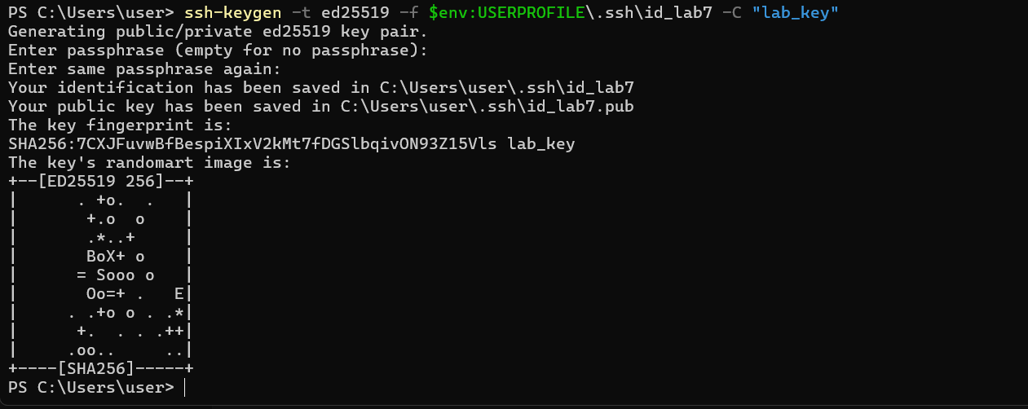
- Show the public key content (single screenshot):
type $env:USERPROFILE\.ssh\id_lab7.pub# or
on Git Bash: cat ~/.ssh/id_lab7.pub
Save screenshot as: task6_windows_public_key.png
- Clear the known_hosts file content and verify it is empty (single screenshot):
# Clear contents (PowerShell)Clear-Content $env:USERPROFILE\.ssh\known_hosts
# View the file (should be empty)
type $env:USERPROFILE\.ssh\known_hosts
Save screenshot as: task6_windows_known_hosts_cleared_and_empty.png
- Connect to the Ubuntu server using the standard SSH command (this will prompt to accept the server host key because known_hosts is empty). Capture the connection prompt/accept step in one screenshot:
ssh username@<server_ip># Accept the host key prompt (yes) and complete the login (enter password or key passphrase)
Save screenshot as: task6_windows_ssh_accept_hostkey_and_login.png
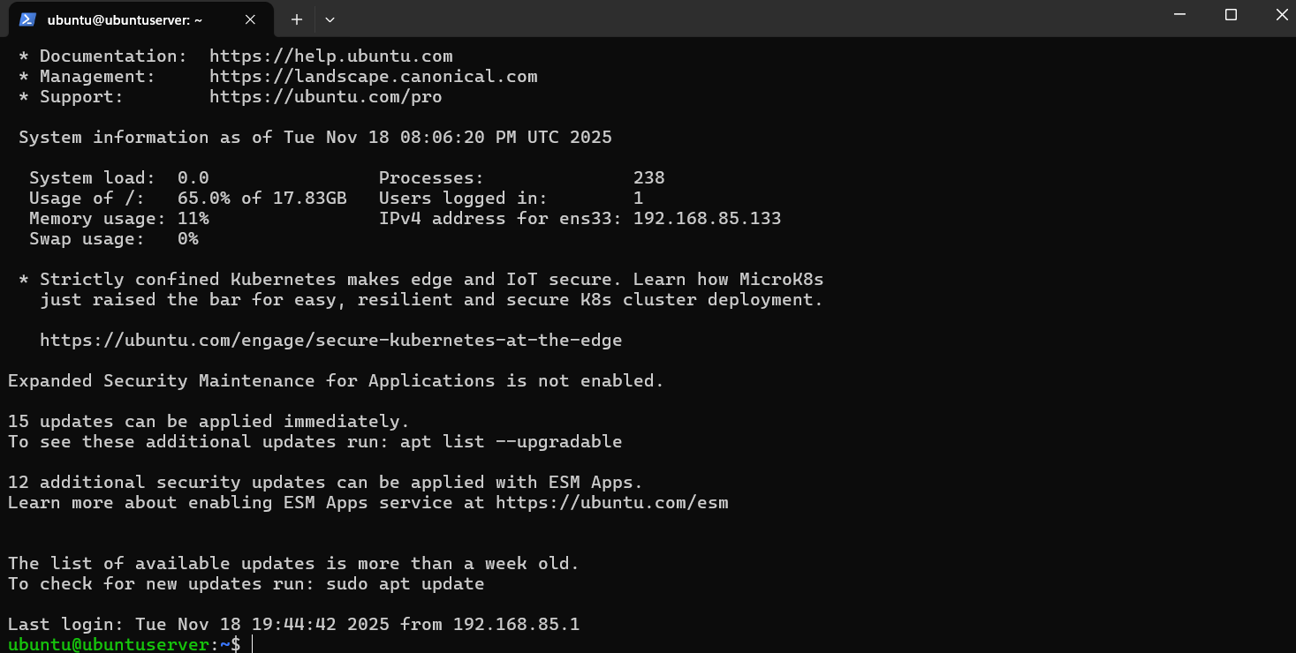
- After the successful connection, view the known_hosts file to show the server host key was added (single screenshot):
type $env:USERPROFILE\.ssh\known_hosts
Save screenshot as: task6_windows_known_hosts_after_connect.png
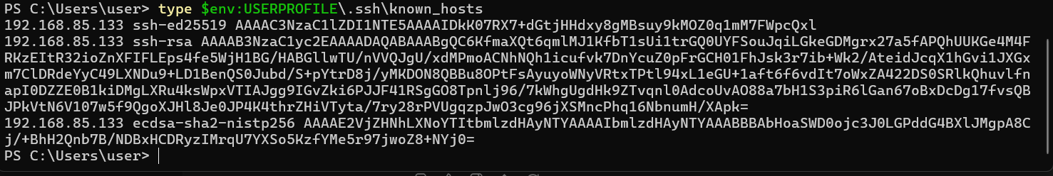
B. On Ubuntu server — group related server-side commands:
1. Prepare the ~/.ssh directory and clear authorized_keys (this will create the directory if missing, set the correct directory permissions, and truncate the authorized_keys file). Capture this command sequence and its output in one screenshot:
mkdir -p ~/.ssh
chmod 700 ~/.ssh> ~/.ssh/authorized_keys
Save screenshot as: task6_server_clear_authorized_keys.png
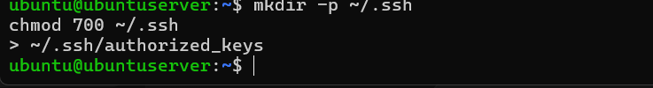
2.Append the public key, set file permissions, and show the resulting authorized_keys (capture commands and resulting file content in one screenshot):
# paste public key name id_lab7.pub from Windows client into the echo belowecho "ssh-ed25519 AAAA... yourpublickey ... comment" >> ~/.ssh/authorized_keys
chmod 600 ~/.ssh/authorized_keys
cat ~/.ssh/authorized_keys
Save screenshot as: task6_server_add_key_and_show.png (single screenshot showing the commands and resulting authorized_keys content)
- From Windows host test passwordless login (capture successful login in one screenshot):
ssh username@<server_ip>
Save screenshot as: task6_ssh_passwordless_login.png
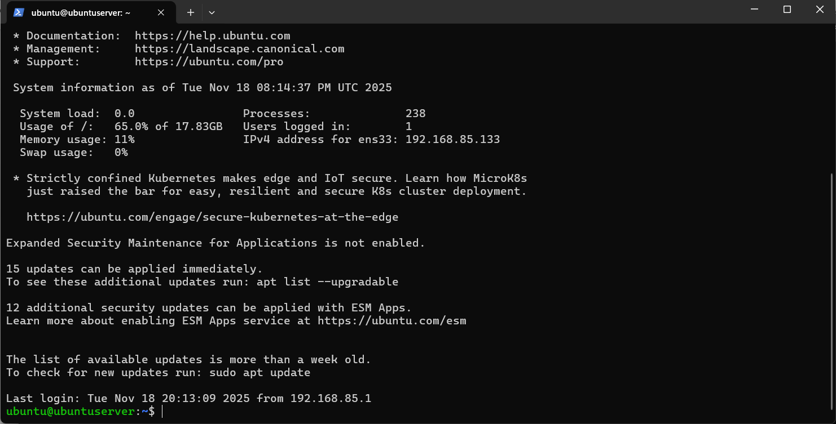
- Also demonstrate explicit identity usage (single screenshot):
ssh -i ~/.ssh/id_lab7 username@<server_ip>
Save screenshot as: task6_ssh_with_identity_file.png
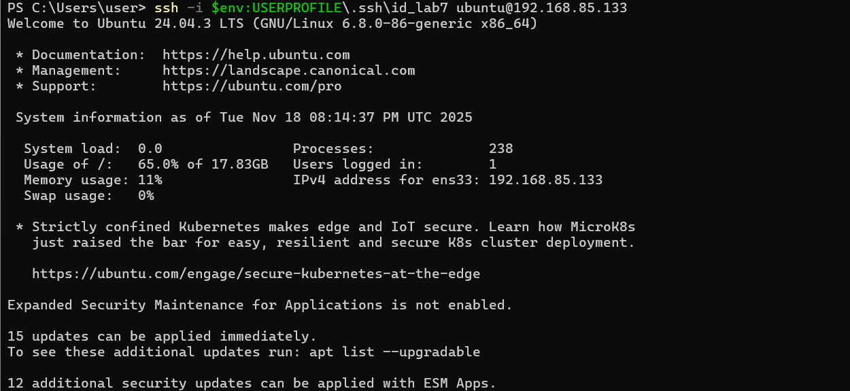
Exam Evaluation Questions

Q1: Quick Environment Audit
Objective: Demonstrate you can inspect the current environment and extract a few key variables.
Actions & evidence:
- Run a single command to display environment variables and capture its output.
- Save screenshot: EE_q1_env_all.png
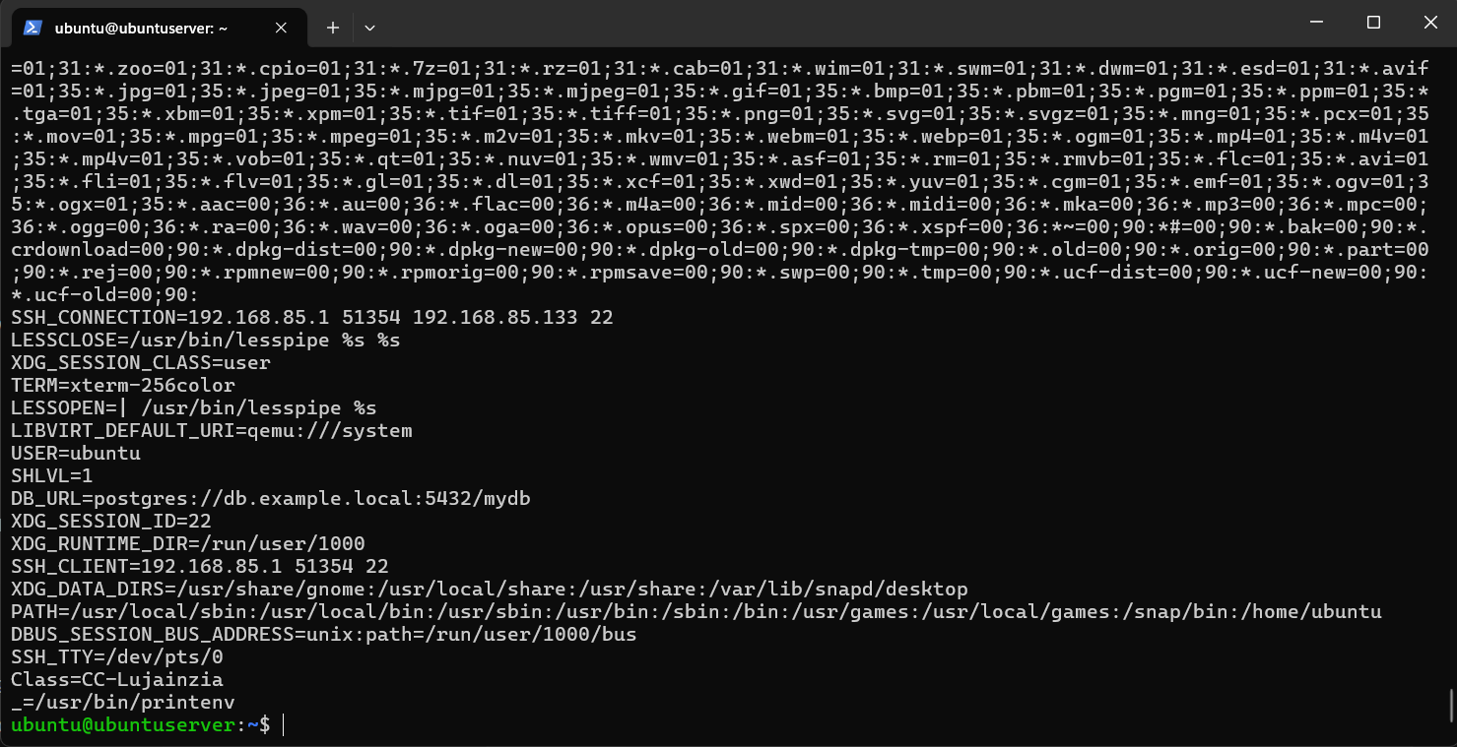
- In the same terminal session, run three filters (one per line) to show values for PATH, LANG, and PWD, then capture a single screenshot showing the three outputs together.
- Save screenshot: EE_q1_env_filters.png
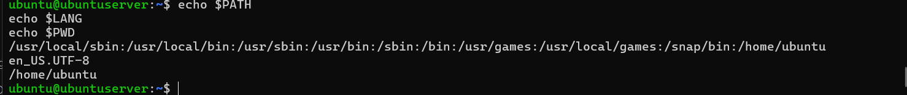
Q2: Short-lived Student Info

Objective: Show how temporary environment variables behave (session-scoped).
Actions & evidence:
- In one terminal, set three variables (STUDENT_NAME, STUDENT_ROLL_NUMBER, STUDENT_SEMESTER) using export — execute all three consecutively and capture them in one screenshot (show the commands executed).
- Save screenshot: EE_q2_exports.png
- Still in the same session, print the three values with echo (grouped) and capture the outputs in one screenshot.
- Save screenshot: EE_q2_echoes.png
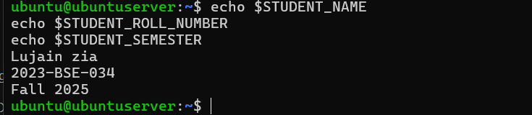
- Use a single printenv|grep command to list any STUDENT_ variables and capture the result.
- Save screenshot: EE_q2_printenv_grep.png
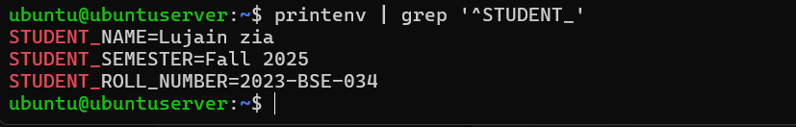
- Exit that shell, open a fresh terminal, and show that the STUDENT_ variables are not set (use echo and printenv|grep together) — capture in one screenshot.
- Save screenshot: EE_q2_after_restart.png
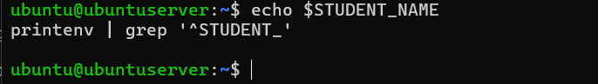
Q3: Make It Sticky (Persistence Check for Student Info)

Objective: Demonstrate persistence of environment variables across sessions via shell configuration.
Actions & evidence:
- Edit ~/.bashrc and append the three STUDENT_* exports. Capture a screenshot of the editor showing the new lines.
- Save screenshot: EE_q3_bashrc_editor.png
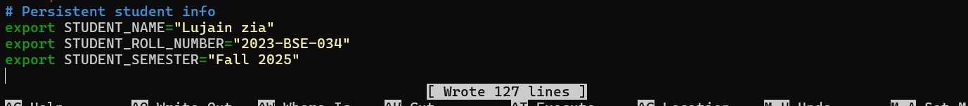
- Reload your shell config with a single command and then verify the three variables and show printenv | grep '^STUDENT_' — capture these verification outputs together in one screenshot.
- Save screenshot: EE_q3_after_source.png
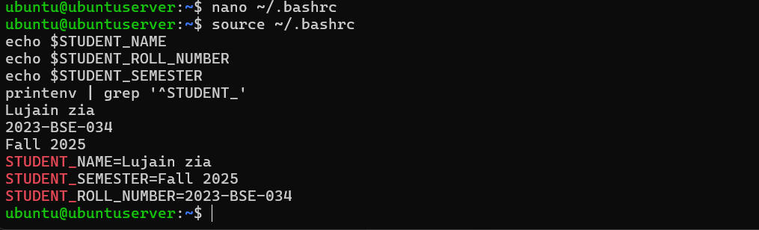
- Close and re-open a terminal and demonstrate the STUDENT_NAME variable is available (echo and printenv grep together) — capture in one screenshot.
- Save screenshot: EE_q3_after_restart.png
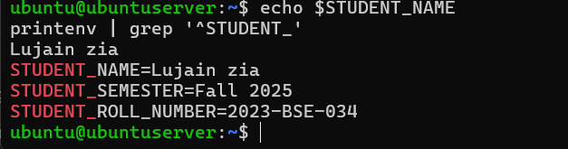
Q4: Firewall Rules: Block and Restore Ping (ICMP)

Objective: Demonstrate you can block ping (ICMP echo) traffic using ufw and then re-allow it; show effect from a client.
Actions & evidence:
- Enable ufw and capture the enable command and status together in one screenshot.
- Save screenshot: EE_q5_ufw_enable_status.png
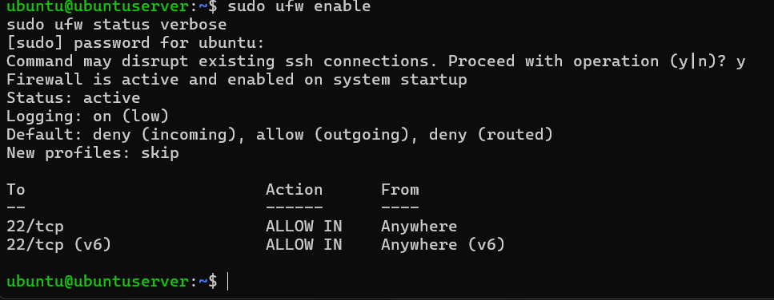
- Add a rule to block ping (ICMP echo) and show ufw status numbered in the same screenshot.
- Suggested command example:
- sudo ufw deny proto icmp from any to any
- sudo ufw status numbered

- Save screenshot: EE_q5_ufw_deny_ping_status.png
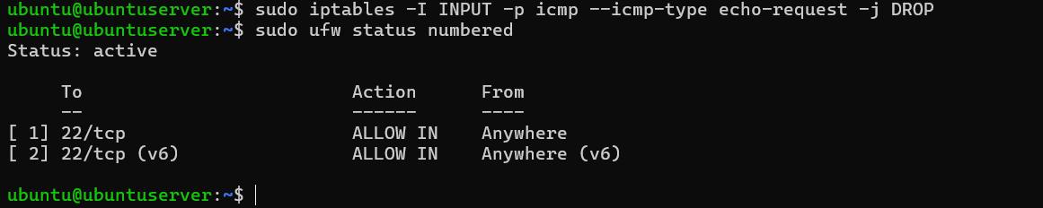
- From your Windows host (or another client), attempt to ping the server while the rule is active and capture the blocked/failing ping in one screenshot.
- Save screenshot: EE_q5_ping_blocked.png
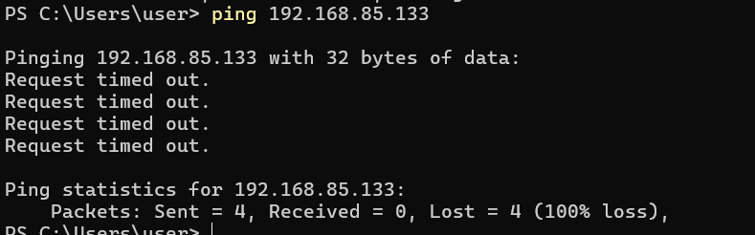
- Re-allow ping (ICMP) (or remove the deny rule) and capture the allow/reload/status sequence in one screenshot.
Suggested command example:
sudo ufw allow proto icmp from any to any
sudo ufw reload
sudo ufw status
- Save screenshot: EE_q5_ufw_allow_ping_status.png
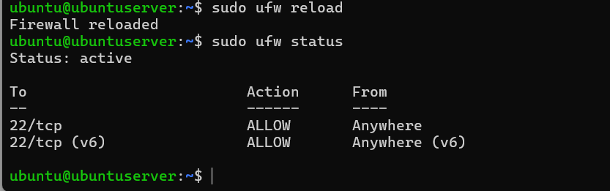
- From the client, ping the server again and capture successful replies in one screenshot.
- Save screenshot: EE_q5_ping_success.png
